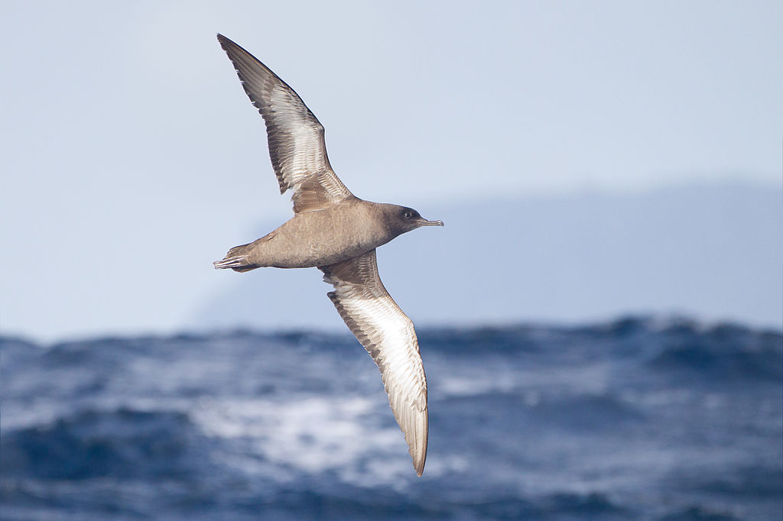**In the beginning...**

SIRCET manages the Halfmoon Bay Habitat Restoration Project which involves controlling animal pests and weeds, monitoring of pests and native species and re-vegetation, over a 210ha area around Halfmoon Bay, focussed on Acker's Point. We have been monitoring the 'Near Threatened' tītī / sooty shearwater/ muttonbird since 2004.

The purpose is to gauge the response of this colony to the pest control in the area by watching the population over time. Nesting success is our main measure of the survival of this colony and this has been monitored mostly using burrow scoping. It seems that the influence of offshore food supply is important for this colony. As this is out of the control of the Trust at this time, SIRCET aims to significantly reduce or completely remove any land-based reasons why these nests might not survive, giving the birds the optimum opportunity to produce a strong, healthy chick which will return to breed in years to come.

*Below: A tītī at Acker's Point colony, almost fully feathered, seen using a burrowscope.*

**Background**

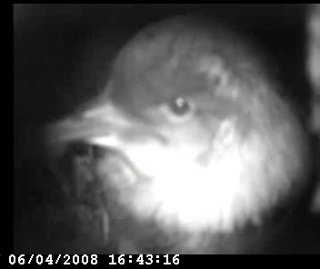Over the past twelve breeding seasons from 2005-2017 there has been a gradual increase in the number of eggs laid, from 34 to a peak of 71 in 2016. This would suggest that a lack of breeding pairs or suitable habitat is not the problem. However, over this time the number of hatched chicks and the number of pre-fledge chicks found has varied dramatically from season to season.

The most recent trend (since 2012) is that many eggs are laid and then few or any pre-fledge chicks are found in subsequent checks. The only year that bucks this trend is the 2015/16 breeding year when 57 pre-fledge chicks were found, showing that the colony can still produce chicks in large numbers under the right conditions.

Unfortunately, we did not find any pre-fledge chicks in four out of the last five breeding seasons monitored using burrow scoping, leaving Trustees with the question of what is happening between the eggs being laid and chicks hatching and fledging.

**April 2018**

Trail cameras were kindly donated by Stewart Island Experience. In mid-April three trail cameras were deployed in the colony over five nights, to try and get an idea of what tītī and/or predators or competitors were found in the colony at those sites. The theory was that predation of eggs and chicks was causing low fledging success in the last five years. Either presence of predators and / or predations events might be captured by the trail cameras. The high rat number observed in the colony during this time was considered important.

*Above: Tītī monitoring results, showing number (eggs / chicks / fledglings) across years*

